**Review and reflection.**

I enrolled at Shengeza High School at the birth of the new millennium in year 2000, at the time when it was not fashionable to be a Shengeza High learner due to the then poor performance of the school. I have a very little memory of the earlier years, but I can recall that when Mr M Manyapye took over as the headmaster in 2001/2002 things started to change and discipline became the order of the day despite limited teaching resources. We did not have textbooks, libraries, computers nor laboratories. However, the senior educators of the school (i.e. Mr Mhlongo, S Mkhize, SS Ngubane, etc) and arrival of educators from other provinces (i.e. Ms Rapagkadi) really stabilized the school’s performance. The journey was a challenging one, but dedication, hard work, sacrifices and support from the teachers kept us going.

I was the first matriculant to obtain 4 distinctions coming from Shengeza High School in 2004, and since then the school has been doing well as I have been following its matric performance over the years. From what I have recently observed, the school is now anchored by local educators who understand the socioeconomic dynamics of the area. This is definitely adding value in propelling the performance of the school and will go a long way in shaping the culture and identity of the school as a community institution.

What I would like to say as an advice to current learners is that they must keep their heads up as their current situation does not define their destination. They must grab every opportunity presented and should not shy from embracing or even becoming part of changes dominated by technological advancements.

Mr Njomane used to say “Scorn the delight and live a laborious life”

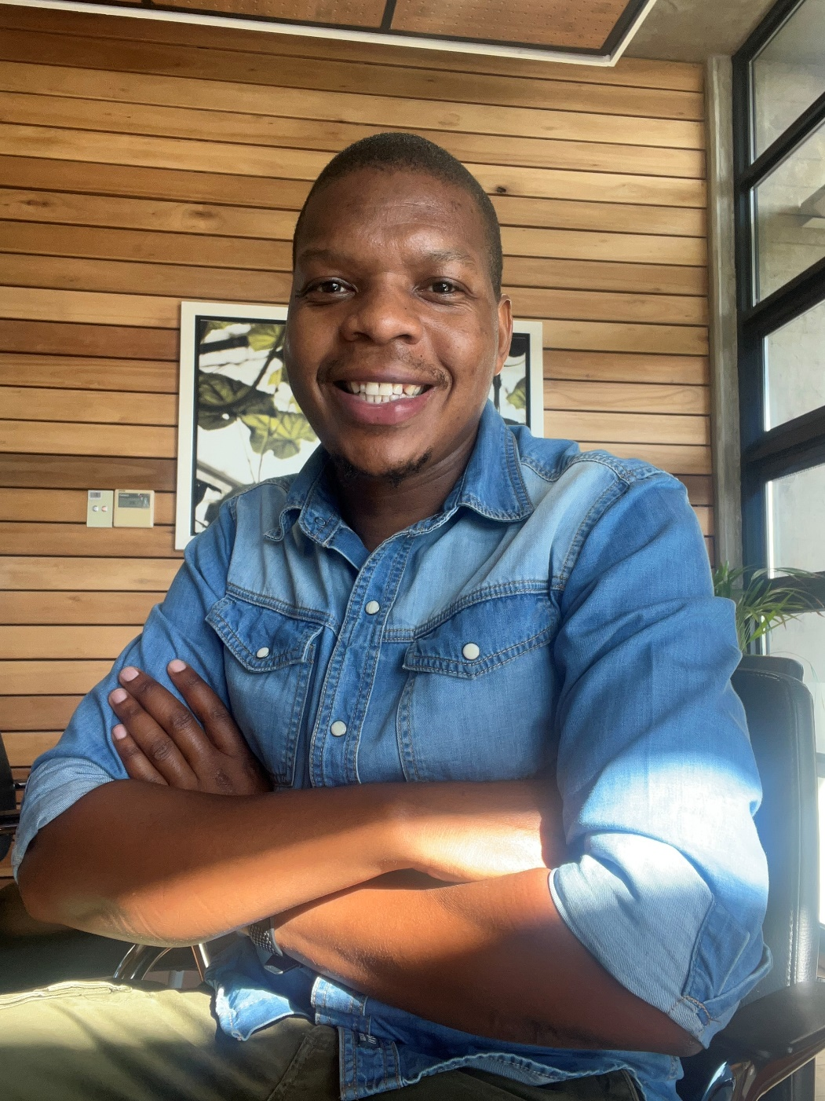

Nkosinathi Nsele